Ladies' Breakfast
In September the ladies of the WF began their autumn session with a Saturday morning meeting in the Adair Arms Hotel.
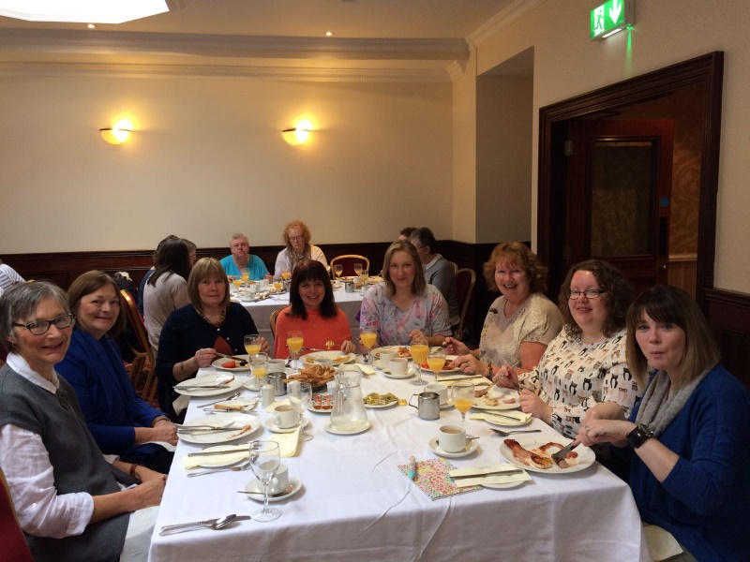
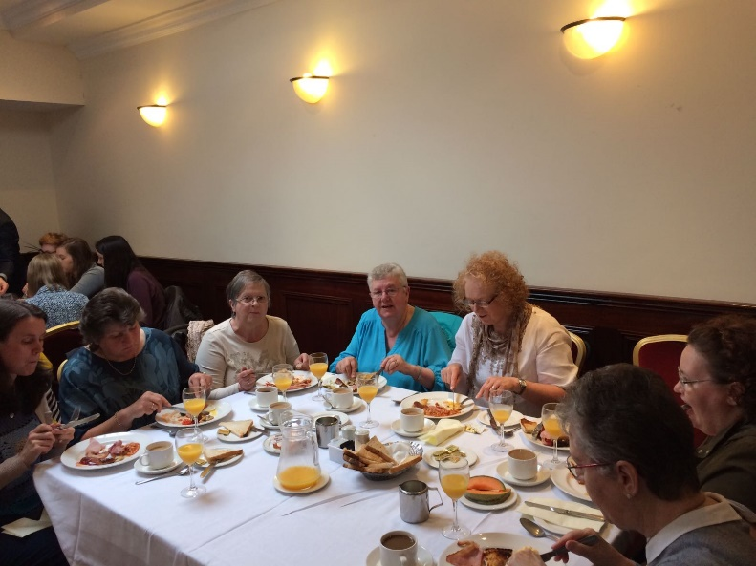
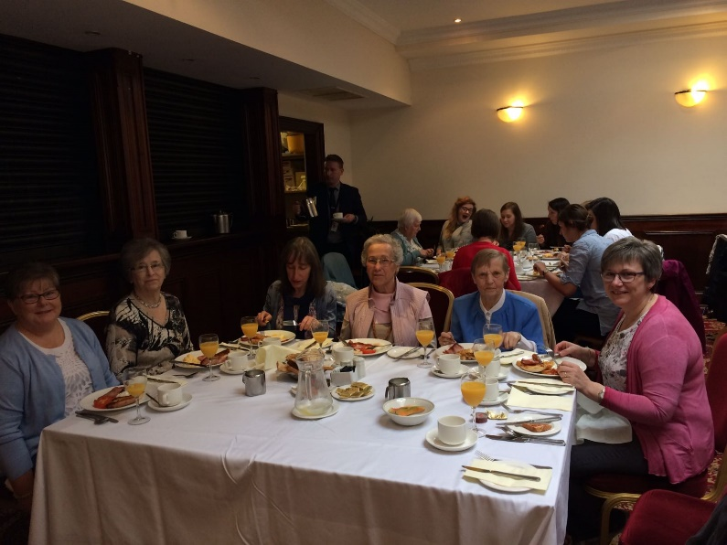
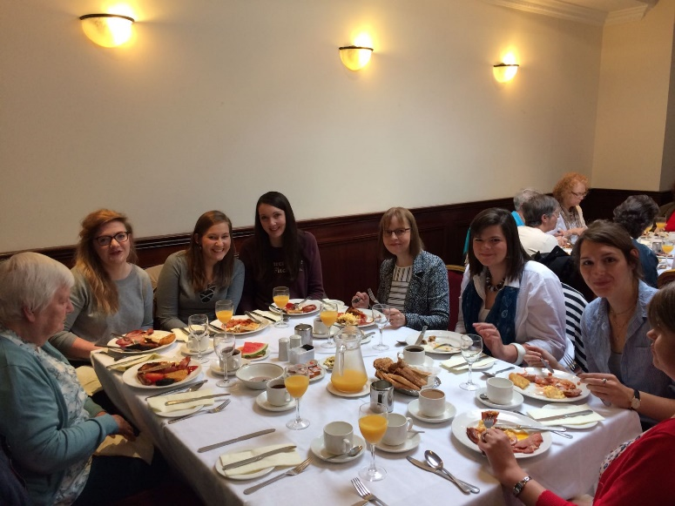

After a delicious breakfast we were pleased to welcome our speaker Miss Brenda Kelso, whose theme was "Hope for Modern Living", based on
Romans 15 v 13
'May the God of hope fill you with all joy and peace in believing,
so that by the power of the Holy Spirit you may abound in hope.'
Brenda helped us to recognise the 'busyness' of life, to understand the pressures we face; to know ourselves and what thoughts trouble us; to learn self-care.
Brenda reminded us that we need to understand the battle we face in everyday life – we live in a fallen world and face both external and internal stressors.
We were challenged to know ourselves better – to identify if our hearts are ruled by fear and anxiety or if we are secure in the knowledge of the grace of God.
Finally we were encouraged to take care of ourselves physically, mentally, spiritually and emotionally. We all need good diet, good exercise, good sleep, good social interaction and a good spiritual diet. We need to guard our thoughts and focus on truth, taking time to reflect on e.g. Psalm 86, Psalm 121, Psalm 130.
We found it encouraging to be reminded that God provides us with hope on life’s journey. He gives us grace for the journey, having given us freedom in Christ and a relationship with him. He also gives us a most powerful relationship, the in-dwelling Holy Spirit. How wonderful it is to know that even in times of sorrow and suffering we have God’s peace.
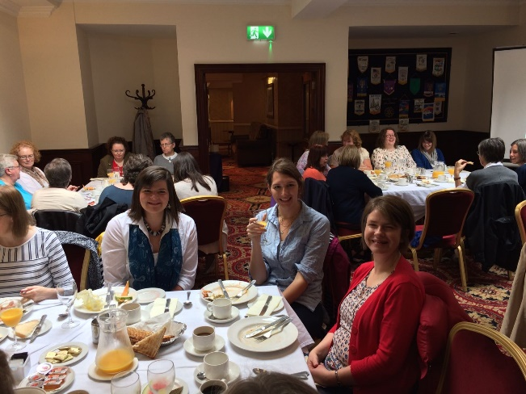
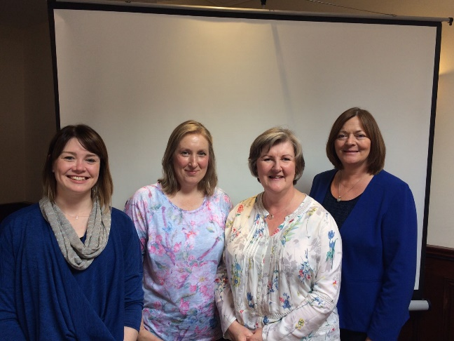

Our morning finished with tea and coffee and a time to chat and discuss what we had learned from this powerful verse from the Letter to the Romans.
